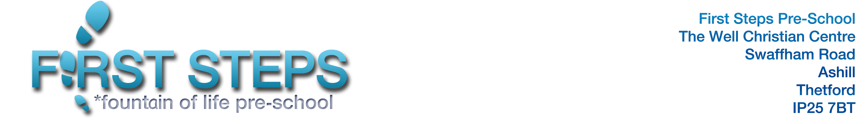

PLACE REQUEST FORM
PLEASE NOTE COMPLETION OF THIS FORM IS NOT A GUARANTEE OF A PLACE
Name of child
Date of birth
Address
Parent/carer name(s)
Contact tel no
Email
Requested start date - Start of Autumn Term Start of Spring Term Start of Summer Term
Please note - Start dates may be staggered at the start of a term to support the needs of new starters
Requested sessions – please indicate below
Mon am | Mon pm | Tues am | Tues pm | Wed am | Wed pm | Fri am
Are you flexible about which sessions your child attends? Yes / No
Details:

Please circle whether your child will be -
Current entitlements = 3&4 year old funded 15 hours (Universal) 3&4 year old funded 30 hours (Working Parent Entitlement) 2 year old funded 15 hours (households in receipt of government support) 2 year old funded 15 hours (working parent entitlement) Unfunded (fee paying)

If eligible for a 3&4 year old funded 30 hours (working parent entitlement), or 2 year old funded 15 hours (working parent entitlement) please add your code and the NI number and name of the person who set up the account so that we can perform an eligibility check via the Norfolk County Council funding portal
Extended entitlement code- | NI number-
Consent for eligibility check – Please sign and date below

Our fees from September 2023 are £13.65 a session (£4.55 an hour) for 3 and 4 year olds and £14.25 a session (£4.75 an hour) for two year olds. Registration fee is £11.00 as a one-off charge. Consumables are charged at 25p a session for funded places (this charge is voluntary but is essential for us to maintain our provision). If there is a shortfall on your child’s funding for the term, this will be charged at the relevant sessional rate. Charges will be detailed on your termly invoice and can also be seen in our Charging Policy.
Please return this form to rrfirststeps@gmail.com and we will contact you to acknowledge receipt. Please note that First Steps has a policy regarding the operation of a waiting list should a place not be immediately available, or your child is under the age of two at the time of completing this form. There may also be sessions where we have limited availability. We aim to give priority for start dates each term in line with our Admissions Policy. We will confirm acceptance of a place two months before your requested start date and will issue a full Registration Form and other documents we need prior to starting. Lou will also be in touch regarding an induction. Please look out for these emails. Note that Privacy Notices and other information can be found on our website www.firststepsashill.co.uk
Office Use:
Date request received – Admissions Number –
Confirmation of whether place available due by -
Place Offer Details – Parent/Care acceptance of offer - Y / N

